 CHEMICAL ENGINEERING TRANSACTIONS  VOL. xxx, 2025 | A publication of  
The Italian Association
of Chemical Engineering
Online at www.cetjournal.it
Guest Editors: Bruno Fabiano, Valerio Cozzani
Copyright © 2025, AIDIC Servizi S.r.l.
ISBN 979-12-81206-xx-y; ISSN 2283-9216

Assessing the Major Industrial Accident Potential Based on Dangerous Substance Criteria: A Framework for Seveso and non-Seveso Facilities.
David J. Castro Rodriguez^{a,}*, Huxiao Shiª, Morena Vitaleª, Micaela Demichela^{a,}, Antonello A. Barresiª.
ª Department of Applied Science and Technology (DISAT)/ Politecnico di Torino, Italy.
david.castro@polito.it
In Europe, a major accident is defined as an uncontrolled event like a major emission, fire, or explosion involving dangerous substances, posing immediate or delayed risks to human health and the environment, as stipulated in the Seveso III Directive (2012/18/EU). According to Seveso III, establishments are classified as lower-tier (LTE) and upper-tier (UTE) based on their maximum storage capacity of dangerous substances. Regarding the substance criteria, the European Commission requires notifications of eventual major accidents when at least 5% of the UTE is involved. However, plants outside Seveso III can also meet the previous criteria causing major accidents, even if they are not covered by the safety minimal requirements within the European Directive. This study addresses this limitation by proposing a framework for assessing the potential for major industrial accidents based on dangerous substance criteria, regardless of whether the plant is classified as a Seveso establishment or not. Substance classification and quantification were kept under Annex I of the Seveso III Directive, considering the potential consequences for human health, the environment, and physic-built infrastructure. The dangerousness potential of the hazardous substances was defined based on the consequences of potential scenarios such as toxic releases, energetic events, and large spills. Subsequently, the total index of compliance was determined for each dangerousness category. This index calculates the ratio between stored hazardous substances and their corresponding upper threshold. A linear decisional scale based on the compliance index was established, clustering plants into seven colour zones according to their major accident potentiality and establishing a cutoff point according the 5 % UTE criteria. Anonymized case study data exemplifies this method. This framework improves the assessment of the inherent hazard associated with the stored amounts of dangerous substances, providing a more nuanced method for increase the awareness to major accidents hazard and introducing safety measures in both Seveso and non-Seveso facilities.
Keywords: dangerous substances, major accidents, non-Seveso facilities, Seveso establishments.
  - Introduction
At an European level, a major accident, as per the latest Seveso III Directive (201218/EU), refers to the “occurrence such as a major emission, fire, or explosion resulting from uncontrolled developments in the course of the operation of any establishment covered by this Directive and leading to serious danger to human health or the environment, immediate or delayed, inside or outside the establishment, and involving one or more dangerous substances". According to Seveso III, the establishments are classified as lower-tier establishments (LTE) or upper-tier establishments (UTE). This classification is based on their maximum capacity for storing dangerous substances, compared to the specified amounts outlined in columns 2 and 3 of Annex I of the European Directive (2012/18/EU). Moreover, Annex VI of Directive 2012/18/EU establishes criteria for the notification of a major accident to the European Commission, which considers several items grouped into five dimensions. The criteria include: i) the involvement of a dangerous substance; ii) injuries to persons and damage to real estate; iii) immediate damage to the environment; iv) property damage; and v) cross-border damage. However, facilities that are not covered under Seveso III (and therefore outside of certain minimal safety constraints set on the Seveso framework) can generate major accidents satisfying the requirements in Annex VI of Directive (2012/18/EU). For example, regarding the initial criterion (the presence of a hazardous substance), this could involve a complete loss of containment of the hazardous substance inventory in a hypothetical facility due to the failure of storage equipment in a technological scenario. If this facility had a storage capacity between 5% and 10% of the upper threshold specified in Directive 2012/18/EU, while the plant is neither classified as UTE nor LTE, it has the potential to create a significant accident.
To prevent major accidents and improve risk management, it is crucial to develop leading indicators (Jain et al., 2017), which include not only the analysis of Seveso facilities but also other facilities, offering valuable information on finding signals to anticipate potential disaster involving the dangerous substance in storage. In this line, previous authors also looked at using rating-based systems (Pilone et al., 2021; 2022), which would be a consistent way to make decisions when examining at the harmonized system of classifying dangerous substances used by Seveso establishments. However, some opportunities to improve these ideas are presented in this work. From these issues, the goal of this research was to assess the potential of industrial plants to cause major accidents. It was achieved by implementing a metric based on criteria related to the dangerousness and quantity of hazardous substances in storage, regardless of whether the facilities are classified as Seveso or non-Seveso.
  - Materials and Methods
This section is split into the general description of the plants used as anonymized case studies and the methodology for calculating the major industrial accident potentiality based on dangerous substance criteria.
    - Anonymized industrial plants used as a case study
On the one hand, Plant A consisted of typical industrial typology clustered in the macro-sector “chemical and petrochemical industry” (Casson Moreno et al., 2018). Its specific activity is the production of lubricants and oil additives, where both the principal raw materials used, and the final products, are mostly chemicals. The unit operations that are carried out in the plant are both chemical (neutralization, carbonation, polymerization) and physical (distillation, filtration, blending). The activities also include auxiliary technical systems necessary for the operation of the production plant, such as compressed air production and distribution, treatment of wastewater, steam production, and nitrogen supply (Castro Rodriguez et al., 2023a).
On the other hand, Plant B corresponds to a plant clustered in the category “Power production”; its specific activity is the power production from the combustion of hydrocarbons (Casson Moreno et al., 2018). The unit operations that are carried out in the plant are both chemical and physical. The activities also in this case include auxiliary technical systems necessary for the operation of the plan, such as compressed air distribution, treatment of wastewater, steam production, and warehousing. Within all the processes and functions of the plant, the following items were identified: atmospheric storage tanks, tall structures such as chimneys and process columns and equipment, heat exchangers, complex systems of pipelines, complex electrical networks, and water treatment facilities (Castro Rodriguez et al., 2023b).
    - Methodology for calculating the major accidents potentiality based on dangerous substance criteria
Initially, the “type” of hazardous substances (C_{s}) was classified in the following categories: C_{a} (health risks), C_{b} (physical hazards), and C_{c} (environmental hazards), therefore s=⧼a, b, c⧽. These three categories of hazardous substances align with the Globally Harmonized System (GHS) of classification and labelling of chemicals (United Nations, 2023), which is used by Directive 2012/18/EU. These classifications are directly related with the potential scenarios that the adopted categories can generate (toxic, energetic, spills).
For instance, the C_{a} dimension may cluster events such as the Seveso dioxin disaster in 1976, the Manfredonia arsenic dispersion in 1976, or the Lubrizol black smoke accident in 2019, all of them with a huge territorial extension of their toxic scenarios and high severity to human health. Moreover, the C_{b} dimension may include energetic scenarios (fires, explosions) with devasting consequences for both infrastructure and people in the damaged and neighbouring zone. Examples within this category match with those disasters that occurred at Feyzin in 1966, Flixborough in 1974, Dutch State Mines in 1975, Piper Alpha in 1988, Enschede in 2000, Toulouse in 2001, and Buncefield in 2005. Finally, the C_{c} dimension comprises scenarios like the Sandoz chemical spill in 1986, the dike breakage of Aznalcollar in 1998, the Baia Mare mining accidents in 2000, and the Kolontár red mud disaster in 2010, all of them with very long territorial range of their impacts on the environment.
For accurate classifications, the Seveso III Directive provides clear rules as outlined in Note 4, Note 5, and Note 6 of Annex I, which can also be applied to non-Seveso facilities. In brief, this note states that the hazardous substances (including wastes), potentially located in an establishment, shall be provisionally assimilated into the most similar dangerous category or substance listed in Annex I 2012/18/EU. Therefore, if other substances are present, they must be considered in one of the three “C_{s}” categories.
A current limitation of the Seveso framework is the exclusion of potential synergies or interactions between substances in storage (Jain et al., 2017). Since this research is a first attempt to measure the major accident potential of both Seveso and non-Seveso facilities, the synergy between substances is beyond the scope. However, it represents an opportunity for enhancement in future work.
Moving to the quantity of hazardous substances stored in each facility, the index of compliance is used to calculate the ratio between the amount of hazardous substances stored and the corresponding threshold for each specific substance, within each C_{s} category in line with Note 4 Annex I, of the 2012/18/EU Directive.
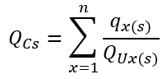 | (1)
where,
Q_{Cs}: is the total index of compliance for the addition of sub-categories of dangerous substances within each of the three C_{s} categories.
x: consist of an alphanumeric code to design any different entry within each subcategory in Column 1 of Part 1 or Part 2 of Annex I of 2012/18/EU Directive.
n: refers to the maximum number of “x” substances held in any subcategory.
q_{x(s)}: is the amount of hazardous substance “x” stored in the plant. The categories of substances are in correspondence with the list of substances present in Column 1 of Part 1 or Part 2 of Annex I of 2012/18/EU for substances classified in each C_{s} category.
Q_{Ux(s)}: is the corresponding upper threshold amount (UTE) for any “x” that is given in Column 3 of Part 1 or Column 3 of Part 2 of Annex I of 2012/18/EU.
The “x” in Eq. (1) can be written in the form “sci” (subcategory-kind of subcategory-consecutive number for different substances). For example, to differentiate two diverse substances in the dimension C_{b} (Physical hazards), within the explosive category, sub-categories “b”, then, C_{b(x)}=C_{b(sci)} →C_{P1b1} (for the first substance) and C_{P1b2} (for the second substance). Using this way each substance can be identified in a univocal way.
Moreover, note 6 of Annex I of Seveso III offers criteria for hazardous substances that, due to their properties, rise to more than one C_{s} classification. For these cases, the lowest threshold quantities (critical) shall be applied for each group of categories (C_{a}, C_{b}, C_{c}) corresponding to the relevant classifications concerned.
Eq. (1) calculates a ratio between the stored substances and upper thresholds. Upper-tier establishments exist (UTE) when Q_{Cs} ≥ 1, while if Q_{Cs}<0.05 for each C_{s} category, the establishment does not have the potential to cause a major accident, based on the consideration that the notification criterion established for the European Commission involves at least 5% of the upper threshold amount (UTE). Therefore, 0.05 represents the cutoff point for Major Accident Potential (MAPP). Figure 1 generalizes the conceptual representation of the framework including a colored decisional scale for Q_{Cs} in function of Q_{Ux(s)}.
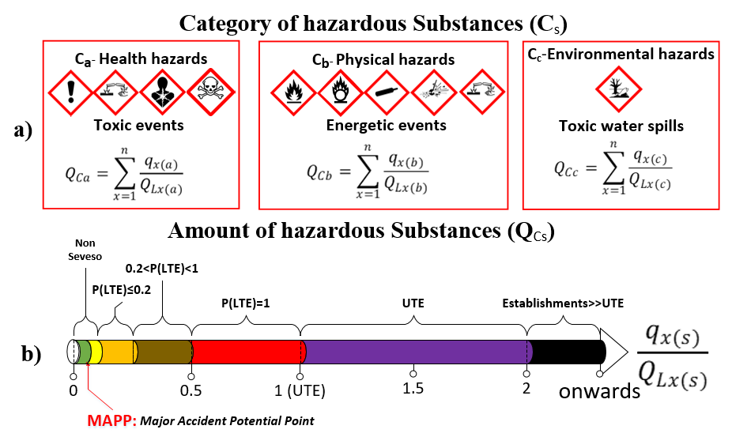
Figure 1: a) Framework representation for assessing the potentiality to cause major industrial accidents based on the dangerous substance criteria. b) Decisional scale for Q_{Cs} in function of Q_{Ux(s)}.
From a mathematical perspective, the compliance index Q_{Cs} can theoretically span the range (0; +ꝏ). However, in practical terms, values beyond Q_{Cs} ≥ 2 are not meaningful, given the evident higher criticality associated with this UTE. Conversely, when a plant falls within the interval [0.05; 1), while it exhibits potential for a major accident, the precise implications of Q_{Cs} within this range are less clear. Notably, this interval includes all lower-tier establishments as well as some other facilities.
To address this point, further analyses were conducted using regulatory data for the 69 threshold quantities listed in Columns 2 and 3 of Annex I in Directive 2012/18/EU. Linear relationships between upper and lower-tier thresholds, as well as their respective 5% (UTE) values, were examined. Additionally, the frequency of Q_{Cs} values within five classes in the interval (0; 1) was analyzed to assess the potential of lower-tier establishments and non-Seveso facilities to fall within each class.
For instance, all the plants in the intervals (0; 0.1) are non-Seveso establishments with 100% confidence. However, this interval is split into two groups: the minor risk facilities in the green zone (0; 0.05) with values that are lower than the MAPP, and facilities in the yellow zone, which are non-Seveso but have the potential to cause a major accident within the range [0.05, 0.1).
Furthermore, in the interval in the orange zone [0.1; 0.25) not only might non-Seveso plants be located with the potential to cause major accidents but also there is a likelihood less than or equal to 20% to find LTE establishments depending on the presence of substances that have lower thresholds in this interval. Similarly, the interval in the brown zone [0.25; 0.5) might encompass non-Seveso plants but here the likelihood of LTE span between 20% and 1. Subsequently, just LTE can be found in the red zone interval [0.5; 1). From the purple zone and onwards (black zone) just UTE can be located [1; 2) and [2; onwards), as previously introduced.
The index of compliance should be calculated separately for each category of C_{s} (Q_{Ca}, Q_{Cb}, Q_{Cc}). The maximum Q_{Cs} value among Q_{Ca}, Q_{Cb}, and Q_{Cc} will be selected to characterize the highest potential to cause major industrial accidents, based on the hazardous substance’s dangerousness. Attention should still be given to the other categories, if they obtain values that fall under color classes holding the potential of major accidents.
  - Results
Table 1 presents the data for the hazardous substances stored in Plants A and B, used as case studies. It includes the denomination, the principal hazards statement, and values for for Q_{Ux(s)}, q_{x(s)}, Q_{Cs}. In addition, the last column clarifies which is the C_{s} critical for each substance (or mixture) under consideration of the note 6 of Annex I, according to the substance that rises to more than one C_{s} classification. Consequently, the critical threshold quantities were applied.
Table 1: Characterization of hazardous substances stored in Plant A and Plant B respectively (in tons).
Case study | Hazardous substance |  | Hazard statements | Q_{Ux(s)} | q_{x(s)} | Q_{Cs} | C_{s} critical
Chemical industry  (Plant A) |  | Methanol | H225, H311, H331 | 200 | 339.0 | 1.6950 | C_{a}
 |  | Toluene | H225, H315, H336 | 200 | 171.0 | 0.8550 | C_{a}
 |  | Methyl Methacrylate | H225, H335, H317 | 500 | 25.4 | 0.0508 | C_{b}
 |  | Automotive Diesel | H411, H226, H315 | 50000 | 3.5 | 0.0001 | C_{b}
 |  | Azobis-methylbutyronitrile (AMBN) | H242, H302, H225, | 200 | 1.0 | 0.0050 | C_{b}
 |  | Sodium hypochlorite | H400, H410, H331 | 200 | 10.0 | 0.0500 | C_{c}
 |  | Mix of raws materials and products (Irgamet 39, methacrylic ester, Zinc dialkyldithiophosphate, Alkyldiphenylamine, phenol derivative, blending mixtures) | H411, H412 H400, H315, H317, H301 | 500 | 708.0 | 1.4160 | C_{c}
 |  | Hazardous waste (API tank foam, sludge, waste oil from maintenance, reclamation sludge, dirty mixed materials) | H411, H304, H315, H318 H335, | 500 | 150.0 | 0.3000 | C_{c}
Power production industry (Plant B) |  | Dense Fuel-Oil BTZ | H411, H226, H315 | 500 | 20000 | 40.0000 | C_{c}
 |  | Automotive Diesel | H411, H226, H315 | 50000 | 100 | 0.0020 | C_{b}

Based on data in Table 1, then Q_{Ca}, Q_{Cb}, and Q_{Cc} were calculated and are presented in Figure 2 for both plants, along with the reference scale Q_{S(ref)} .
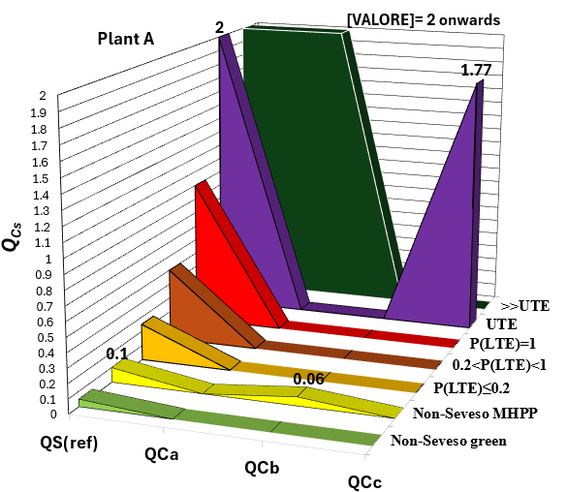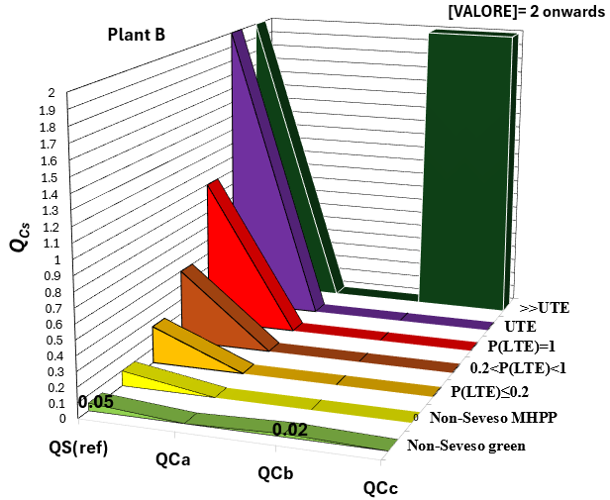
Figure 2: Reference scale for the Index of compliance Q_{S(ref)} in comparison with each dimension Q_{s}: a) Plant A (chemical industry). b) Plant B (power production industry).
For example, in Figure 2 a) the amount of Toluene and Methanol characterizes the potential of this plant concerning the toxic scenarios in the black zone: it means that large toxic scenarios may happen according to the substance detained in this upper-tier establishment. Although the amount of substances linked to the occurrence of energetic scenarios resulted in the strata of minor risk facilities, these quantities have yet the potential to cause a major accident. Finally, the mix of raw materials and waste classified as dangerous to the environment matches the purple classification, translated into the potential to cause major catastrophic accidents with impact on the aquatic environment.
Moving to Figure 2 b), while any substances from the health hazards category were present, it can be appreciated how the quantified presence of substances belonging to the category of physical hazards falls under the minor risk facilities, even below the MAPP (0.02). On the contrary, the dimension of environmental hazard surpasses the upper bounded value for extremely critical UTE, which aligns with the high quantity of combustible stored in the power production plant for its transformation into energy.
Another visualization of previous data is offered in Figure 3, where the ratings obtained for Q_{Ca}, Q_{Cb}, and Q_{Cc} are represented across the different colour classes of Q_{Cs} scale (refer to Figure1).
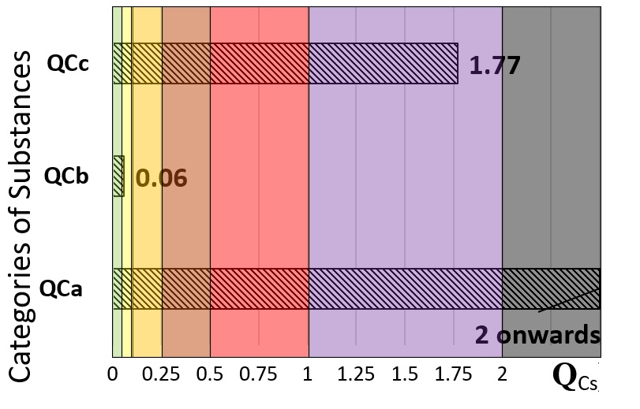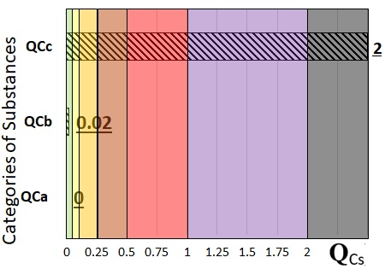
Figure 3: Reference scale for the Index of compliance Q_{S(ref)} in comparison with each dimension Q_{s}: a) Plant A (chemical industry). b) Plant B (power production industry).
Summarizing, the potential of major toxic scenarios in Plant A may arise in case of accidents, with catastrophic consequences for the people involved (C_{a}). It is noteworthy that spills of substances with an impact on the environment can also create major disasters (C_{c}). In conclusion, plant A is an industry that requires special control and monitoring by regulators and local authorities. On the other hand, in Plant B the results highlight the catastrophic consequences associated with chronic toxicity to aquatic life with long-lasting effects in case of a major accident (C_{c}).
  - Conclusions
Here is presented a comprehensive framework for assessing the potential for major accidents extending the effective safety management ensured by European regulations to companies that are not subject to these regulations but may still present significant risks. Additionally, it aims to enhance support for design and operational decisions in major establishments by introducing a more detailed risk-based classification.
Two case studies from different upper-tier establishments belonging to different industrial macro-sectors illustrated the methodology application, demonstrating the utility of the framework in alerting high-risk scenarios.
The outcomes help guide stakeholder oversight in enhancing safety protocols and barriers tailored to critical scenarios that may arise across various industrial sectors. Additionally, they support multi-risk assessments based on the remaining established criteria for reporting major accidents.
The insights provided offer valuable discussion points for regulators and policymakers, particularly in strengthening the current Seveso legal framework, which has not been updated or amended since 2012. Furthermore, this research has implications for policymakers and industry stakeholders in light of the upcoming transposition of Directive (EU) 2022/2557 on the resilience of critical entities. Under this directive, the criticality of an entity is determined based on the essential services it provides to the community, regardless of whether the facility is classified as Seveso or non-Seveso. Hence, integral risk assessment, aiming to be comprehensive in addressing all hazards, is envisioned in alignment with the Sendai Framework for Disaster Risk Reduction, where the substance criteria might create interplay with other risks.
Acknowledgments
This study was carried out within the RETURN Extended Partnership and received funding from the European Union Next-GenerationEU (National Recovery and Resilience Plan – NRRP, Mission 4, Component 2, Investment 1.3 – D.D. 1243 2/8/2022, PE0000005).
References
Casson Moreno, V., Reniers, G., Salzano, E., Cozzani, V., 2018, Analysis of physical and cyber security-related events in the chemical and process industry, Process Safety and Environmental Protection 116, 621–631. <10.1016/j.psep.2018.03.026>
Castro Rodriguez, D.J., Pilone, E., Camuncoli, G., Demichela, M., 2023a, Implementation of a NaTech vulnerability index in a Seveso plant, Chemical Engineering Transactions 100, 43–48. <10.3303/CET23100008>
Castro Rodriguez, D.J., Demichela, M., Beltramino, S., Scalas, M., Brunetta, G., Barresi, A., 2023b, Vulnerability scenario characterization in an industrial context using a NaTech indicator and a territorial multi-risk approach, in: Proceeding of the 33rd European Safety and Reliability Conference (ESREL 2023), 3rd September – 7th September, Southampton, UK, pp, 2181–2188, <10.3850/978-981-18-8071-1_P187-cd>
Castro Rodriguez, D.J., 2024. Modelling Industrial Vulnerabilities within a Multi-hazard Framework for the Resilience of the Territories. PhD Thesis, Politecnico di Torino, Turin, Italy. URL: <iris.polito.it/handle/11583/2994414>
Jain, P., Pasman, H.J., Waldram, S.P., Rogers, W.J., Mannan, M.S., 2017, Did we learn about risk control since Seveso? Yes, we surely did, but is it enough? An historical brief and problem analysis, Journal of Loss Prevention in the Process Industries 49, Part A, 5–17. <10.1016/j.jlp.2016.09.023>
Pilone, E., Demichela, M., Camuncoli, G., 2021, A NaTech vulnerability indicator for local planners, in: Proceedings of the 31st European Safety and Reliability Conference (ESREL 2021), (B. Castanier, M. Cepin, D. Bigaud, and C. Berenguer, Eds.), Research Publishing, Singapore, pp. 184–191. <10.3850/978-981-18-2016-8 361-cd>
Pilone, E., Demichela, M., Camuncoli, G., 2022, Na-Tech Risk: A new challenge for local planners, Chemical Engineering Transactions 90, 223–228<10.3303/CET2290038>
United Nations (Ed.), 2023. Globally harmonized system of classification and labelling of chemicals (GHS), ST/SG/AC.10/30/Rev.10, Tenth revised edition. United Nations, New York and Geneva.

